

Enterprise development standards

TOOLS AND TECHNOLOGIES

© The Marlborough Stirling Canada 2007

Version: 1.0

Jun 21, 2007

CONTENTS
Revision History iii
1 Introduction 1
2 Standards To Support Business Objectives and Drive Outcomes 2
3 Systems Development Life Cycle Process/Methodology 4
4 Security 5
5 Enterprise Development Standards 6
5.1 Data Management 7
5.2 Platform and Language (Microsoft Solutions) 9
5.3 Platform and Languages (Java Solutions) 12
5.4 Developer Tools 14
5.5 Middleware 17
5.6 Integration Tools 19
5.7 Quality Assurance and Solution Support Tools 20
5.8 Presentation 21
5.9 Reporting & Analysis 23
6 Governance Process for Maintaining and Evolving Standards 24
6.1 Scope of Governance Process 24
6.2 Process Summary 24

Revision History

Date | Version | Description | Author | Reviewed By
Jun 21, 2007 | 1.0 | Initial Draft | Nagesh Chawla

Introduction
This document details Enterprise Development Standards - Tools & Technologies for Marlborough Stirling Canada (MSC). The articulated Standards outlined in this document are meant to provide greater clarity to the development teams as new solutions are developed and/or as plans are made for further evolution of existing systems.

It is the intent of this document to articulate standards associated with the application development process for which MSC will continue to invest and provide a supporting infrastructure. It is not the intent of this document to articulate a standard for each and every process step, tool, or component that goes into the creation of a solution – rather, this document should be used as a reference point for “answers” to the more frequently asked questions. Separate documents will be provided to articulate standards specific to .NET coding, SQL Server etc.

Standards To Support Business Objectives and Drive Outcomes
MSC is continuing the implementation of a technology strategy. As the organization works to streamline application development and increase application capabilities and performance there is increased emphasis on the need for a common application development framework and associated standards. The objective of these enterprise development standards is to improve the way in which we:
- Leverage intellectual capital gained through the development of common tools and platforms.
- Facilitate increased sharing and integration of applications across practice, function, and geographies (across Canada and UK).
- Share common object models and tools.
- Solidify and capitalize on vendor relationships – benefiting from access to emerging products, the best talent available, and potential financial incentives.

These standards have been based on MSC’s business drivers listed below:
- Retaining and growing client business.
- Globalization of the firm (with respect to UK).
- Enhancing employee productivity.
- Increasing organizational effectiveness (and minimizing risk).
- Ensuring technological competitiveness.

As a result, these standards have been built on a number of principles that support these business drivers. As a result, it has been determined that a standard must…
- Support practice, function, and geography innovation.
- Provide a high-degree of reusability and leveragability of our technology resources.
- Focus on maximizing development and support efficiency with minimal business and technology risk.
- Focus on a consistent way technology is used and presented to internal and external users.
- Represent market strength and best practices.
- Support an accelerated speed of market in order to meet and exceed client expectations.
Should it be found that there is a business need that is not supported by these standards or a business case demonstrates a standard is not appropriate, please refer to the governance process outlined in section 6.

The remainder of this document deals with an overview of the development methodology (section 3), the development standards (section 5).

Systems Development Life Cycle Process/Methodology
Before detailing the technical standards that would dictate the types of tools to be used in and particular development project, it should, also be noted that there is a standard Methodology and Process that should be followed on these projects. This process is illustrated below:

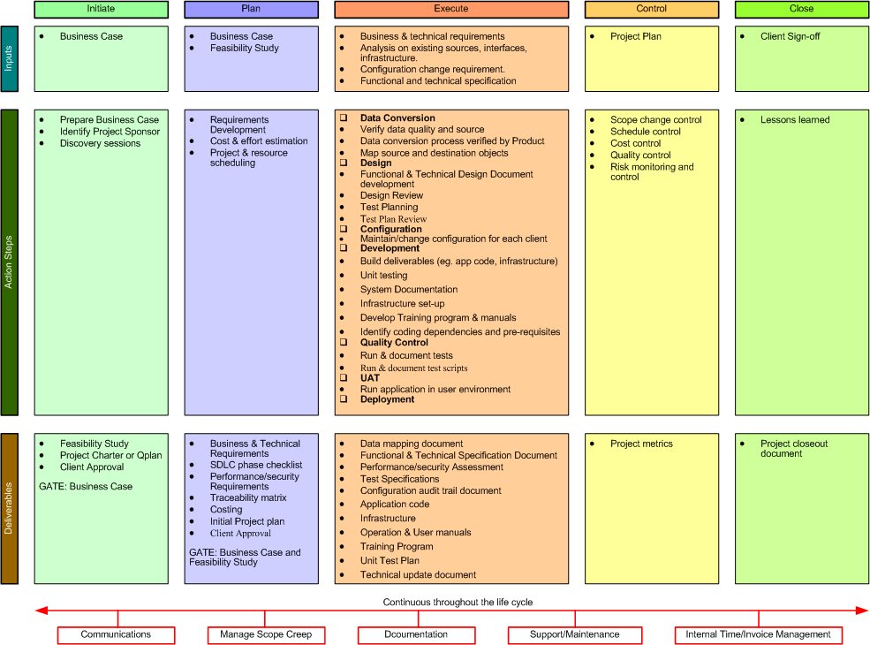

Security
Similar to the need for an underlying methodology, there is also a need to identity a standard approach to security that must govern all development work. This includes security in regards to

Application Development

Application Systems

Cryptographic Controls

Security of System Files

For the purposes of reviewing the standards, the following needs to be considered
Component | Comments
Application Development & Support | The security of the development process is included in the SDLC methodology highlighted in Section 3 and includes the need for Change Control procedures, technical reviews, modification restrictions/controls, etc. The intent is to ensure that security is built into applications (i.e., that security issues are considered when designing the system).
Application Systems | All systems development work must address Input and Output data validation, processing controls and message authentication
Cryptographic Controls | The primary standard is 128 bit encryption (SSL3)
File Security | The primary standard for controlling operation software, source code and test data is PVCS or VSS
RPC Message Security | WS-Security

Enterprise Development Standards
This section includes a listing of the established standards. These standards are divided into sections related to the solution delivery life cycle as follows. The tables in each section identify the key components of the standard for that technical area and are as follows:
- Data Management
- Platform and Languages
- Developer Tools
- Middleware
- Integration Tools
- Quality Assurance and Solution Support Tools
- Presentation
- Reporting and Analysis
Within these sections are separate tables for each component within that section. A component being an area where a standard is required. These tables contain the following:
Current Primary Standard – This is the MSC preferred and approved standard for the respective component. This is the standard that, at a minimum, should be followed for all new solutions that will be deployed for internal and/or client-facing applications.
Current Secondary Standard – The secondary standard provides another acceptable option for solution delivery teams to follow should the primary standard not be suitable.
Evolving Standard – Represents our view of what is evolving technically that will likely become our standard when that technology has matured.
To Be Excluded from Standards – Represents tools currently being used in parts of MSC that will not be supported in the future.
Current Roadmap – Provides further detail on what tools are used today, where they are used and what solutions they support, current licensing, etc.
Future Roadmap – Adds more detail as to when any evolving standard or secondary standard may become a primary and/or details on any approvals, budgetary considerations, etc that will be required.
Rationale/Notes/Issues - This field includes commentary to further define the component and/or to provide clarity around how the standard was chosen.

Data Management
Database Management System
Current Primary Standard | Current Secondary Standard | Evolving Standard | To Be Excluded from Standards
- Microsoft SQL Server 2005 | - DB2 |  | - Microsoft Access
Current Roadmap
Future Roadmap
Rationale/Notes/Issues
SQL Server is already used for most existing enterprise applications. Enterprise Database solutions also require heightened levels of security.

Data Modeling
Current Primary Standard | Current Secondary Standard | Evolving Standard | To Be Excluded from Standards
- ERWin?? | - MS Visio 2003  - Sybase’s Power Designer
Current Roadmap
Future Roadmap
Rationale/Notes/Issues
ERwin supports multiple database platforms, and is relatively easy to use on a standalone basis. Also, ERWin is the market leader.

Data Dictionary (Metadata Tools)
Current Primary Standard | Current Secondary Standard | Evolving Standard | To Be Excluded from Standards
- Platinum Repository | - Microsoft’s Metadata Services
Current Roadmap
Future Roadmap
Rationale/Notes/Issues
Deciding on a standard for a metadata repository is challenging. These tools can be very expensive, and the history of success in organizations is limited. Defining an "approach" or a tool independent "strategy" for dealing with metadata is a more reasonable first step.

Platform and Language (Microsoft Solutions)

Target Platforms
Current Primary Standard | Current Secondary Standard | Evolving Standard | To Be Excluded from Standards
- .NET 2 | - Windows 2003/COM+  - J2EE
Current Roadmap
Future Roadmap
Rationale/Notes/Issues
A platform is the foundation upon which a development language and ultimately end products will operate. A program (end-product), that is built to run under certain platform, can conceptually be portable to all environments that are supported by that platform.

Target Servers
Current Primary Standard | Current Secondary Standard | Evolving Standard | To Be Excluded from Standards
- IIS  - .NET Server | - COM+
Current Roadmap
Future Roadmap
Rationale/Notes/Issues
IIS (Internet Information Server) is an existing investment within MSC. Also, we are presently developing competencies for the .NET environment.

Development Languages/IDEs
Current Primary Standard | Current Secondary Standard | Evolving Standard | To Be Excluded from Standards
- C#  - ASP.NET  - VB | - Managed C++  - COBOL  - Visual Studio 2005
Current Roadmap
Future Roadmap
Rationale/Notes/Issues
We are presently developing competencies for the .NET environment.

Database Languages
Current Primary Standard | Current Secondary Standard | Evolving Standard | To Be Excluded from Standards
- MS SQL Scripting | - Transact-SQL
Current Roadmap
Future Roadmap
Rationale/Notes/Issues
These are the supported scripting languages.

Scripting Languages
Current Primary Standard | Current Secondary Standard | Evolving Standard | To Be Excluded from Standards
- VBA
- VBScript
- Jscript
Current Roadmap
Future Roadmap
Rationale/Notes/Issues
These scripting languages have long been the standard for Microsoft servers and tools, and they have also been adopted by various IT groups within MSC.

Database Connectivity
Current Primary Standard | Current Secondary Standard | Evolving Standard | To Be Excluded from Standards
- ADO.NET | - ADO  - OLEDB
Current Roadmap
Future Roadmap
Rationale/Notes/Issues
ADO.NET is the standard connectivity tool for Microsoft languages on .NET platform.

Platform and Languages (Java Solutions)

Target Platforms
Current Primary Standard | Current Secondary Standard | Evolving Standard | To Be Excluded from Standards
- J2EE  - COBOL | - AS/400
Current Roadmap
Future Roadmap
Rationale/Notes/Issues
This is an existing standard for Optimus platforms.

Target Servers
Current Primary Standard | Current Secondary Standard | Evolving Standard | To Be Excluded from Standards
- WAS | - Other J2EE compliant servers
Current Roadmap
Future Roadmap
Rationale/Notes/Issues
This is an existing standard for Optimus supporting applications.

Development Languages/IDEs
Current Primary Standard | Current Secondary Standard | Evolving Standard | To Be Excluded from Standards
- J Developer??

Current Roadmap
Future Roadmap
Rationale/Notes/Issues
Existing investment within MSC.

Database Connectivity
Current Primary Standard | Current Secondary Standard | Evolving Standard | To Be Excluded from Standards
- ??
Current Roadmap
Future Roadmap
Rationale/Notes/Issues
This is an existing standard for Optimus environment.

Developer Tools
Visual Modeling Tools
Current Primary Standard | Current Secondary Standard | Evolving Standard | To Be Excluded from Standards
- Visio 2003 | - Visual UML
Current Roadmap
Future Roadmap
Rationale/Notes/Issues
MS Visio 2003 offers greater capabilities especially when dealing with other Microsoft products such as BizTalk.

Web Authoring Tools
Current Primary Standard | Current Secondary Standard | Evolving Standard | To Be Excluded from Standards
- Visual Studio 2005 |  |  | - Front Page
Current Roadmap
Future Roadmap
Rationale/Notes/Issues
There are no other specific tools in practice within MSC.

Emulation Software
Current Primary Standard | Current Secondary Standard | Evolving Standard | To Be Excluded from Standards
- aXes
Current Roadmap
Future Roadmap
Rationale/Notes/Issues
This product is currently used and there is no specific standard.

XML Editors
Current Primary Standard | Current Secondary Standard | Evolving Standard | To Be Excluded from Standards
- XML Spy | - XML Editor
Current Roadmap
Future Roadmap
Rationale/Notes/Issues
XMLSpy is an existing standard. It is also the leading product in the market.

Graphics Design
Current Primary Standard | Current Secondary Standard | Evolving Standard | To Be Excluded from Standards
- ?? |  | - Photoshop  - Paintshop Pro
Current Roadmap
Future Roadmap
Rationale/Notes/Issues
There are no tools used within MSC currently.

Application Installation
Current Primary Standard | Current Secondary Standard | Evolving Standard | To Be Excluded from Standards
- InstallShield | - MS Packaging & Deployment |  | - PC Install
Current Roadmap
Future Roadmap
Rationale/Notes/Issues
MS Packaging & Deployment comes packaged with MS Visual Studio. However, InstallShield is an existing investment and is more powerful in terms of customization and multilingual capabilities.

Help Authoring Tools
Current Primary Standard | Current Secondary Standard | Evolving Standard | To Be Excluded from Standards
- ?? | - ??
Current Roadmap
Future Roadmap
Rationale/Notes/Issues
??

Debugging & Optimization
Current Primary Standard | Current Secondary Standard | Evolving Standard | To Be Excluded from Standards
 |  | - Code Analyzer
Current Roadmap
Future Roadmap
Rationale/Notes/Issues
There’s no existing standard in MSC. It is advisable to wait little longer on this item as we observe emerging solutions for the .NET environment.

Middleware
Application Communication – Messages
Current Primary Standard | Current Secondary Standard | Evolving Standard | To Be Excluded from Standards
- Microsoft MessageQueue  - IBM MQSeries |  | - BizTalk Server 2006
Current Roadmap
Future Roadmap
Rationale/Notes/Issues
Industry Standards

Data Access Middleware
Current Primary Standard | Current Secondary Standard | Evolving Standard | To Be Excluded from Standards
- XML and SOAP
Current Roadmap
Future Roadmap
Rationale/Notes/Issues
Best available

Data Access Middleware - Translators
Current Primary Standard | Current Secondary Standard | Evolving Standard | To Be Excluded from Standards
- DTS (Packaged with SQL Server) |  | - ETL | - Dharma SQL  - Open RDA Servers
Current Roadmap
Future Roadmap
Rationale/Notes/Issues
To extract, transfer or transform data between DB - Packaged with database

Transaction Management
Current Primary Standard | Current Secondary Standard | Evolving Standard | To Be Excluded from Standards
- SQL Server agent  - DTC |  |  | - Redwood
Current Roadmap
Future Roadmap
Rationale/Notes/Issues
Packaged with Database, best available.

Integration Tools
Preferred tools for integration between applications within the enterprise (A2A) and between MSC and our trading partners (B2B) have not yet been identified. This will be addressed in a future version of this document. For reference, contenders in this category may include Microsoft BizTalk Server, WebMethods, Vitria, TIBCO, Vignette.

Application Integration Tools (A2A)
Current Primary Standard | Current Secondary Standard | Evolving Standard | To Be Excluded from Standards
- BizTalk Server 2006
Current Roadmap
Future Roadmap
Rationale/Notes/Issues

Business Integration Tools (B2B)
Current Primary Standard | Current Secondary Standard | Evolving Standard | To Be Excluded from Standards
- BizTalk Server 2006
Current Roadmap
Future Roadmap
Rationale/Notes/Issues

Quality Assurance and Solution Support Tools
Version Control
Current Primary Standard | Current Secondary Standard | Evolving Standard | To Be Excluded from Standards
- VSS

Current Roadmap
Future Roadmap
Rationale/Notes/Issues
VSS- Fully Integrated with Microsoft development tools.

Help Desk Software
Current Primary Standard | Current Secondary Standard | Evolving Standard | To Be Excluded from Standards
- Deuce
Current Roadmap
Future Roadmap
Rationale/Notes/Issues
In-house product.

Bug Fix/Enhancement Tracking
Current Primary Standard | Current Secondary Standard | Evolving Standard | To Be Excluded from Standards
- Deuce
Current Roadmap
Future Roadmap
Rationale/Notes/Issues
In-house product.

Load/Stress Testing
Current Primary Standard | Current Secondary Standard | Evolving Standard | To Be Excluded from Standards
- ??
Current Roadmap
Future Roadmap
Rationale/Notes/Issues

Presentation
Screen Resolution
Current Primary Standard | Current Secondary Standard | Evolving Standard | To Be Excluded from Standards
- 1024 x 768
Current Roadmap
Future Roadmap
Rationale/Notes/Issues

Browser
Current Primary Standard | Current Secondary Standard | Evolving Standard | To Be Excluded from Standards
- MS Internet Explorer (6.0 and greater) | - Netscape (4.7 and greater) |  | - AOL
Current Roadmap
Future Roadmap
Rationale/Notes/Issues
MS IE is the current browser standard within MSC. Since MS Windows is also the current desktop standard, MS IE comes with the standard installation of the Operating System.

Reporting & Analysis
Reporting (Internal)
Current Primary Standard | Current Secondary Standard | Evolving Standard | To Be Excluded from Standards
- Crystal Reports
Current Roadmap
Future Roadmap
Rationale/Notes/Issues
Crystal Reports is current standard within MSC.

Governance Process for Maintaining and Evolving Standards

Scope of Governance Process
The scope of this governance process is to include all:
- Request for clarification of existing standards
- Request for modification of existing standards
- Request for consideration of new standards

Process Summary
The Enterprise Development Standards are “owned” by the Architecture Forum and Product Technology Group. In this regard, all new standards and/or modifications to the existing standards must be approved by the Group. The Architecture Forum is the working group for the Enterprise Development Standards and is responsible to review, research and make recommendations the Product Technology Group. The Group will review and approve appropriate recommendations. Furthermore, the Group will advise the Forum of existing and new areas to consider, research, and make recommendations on given changes in the business environment.

